B.H. COLLEGE
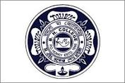
HOWLY:: BARPETA::ASSAM
DEPARTMENT: Education | DATE: 27-01-2024
No. of Students/Participants | 60
Title of the Programme
Orientation Programme for PG students
Name of the Resource Person
Dr. Bhushan Pathak, Principal, B.H. College, Howly
Description of the Programme
An Orientation programme for the PG classes of Assamese and Education held on 27/01/2024 at Seminar Hall of B.H.College Howly. Dr. Bhushan ch. Pathak, Principal, delivered a motivational speech for the students. All the students and Teachers were present at the programme.

